

**Continuing Education Program**

**Center for Computing and Information Technology**

**Fakultas Teknik Universitas Indonesia**

**SUARA SANTRI**

3SC4

Faculty : Ms. Emma Yulianti, S.T, MM

Gedung Pascasarjana Lt.3 Fakultas Teknik-Universitas Indonesia

Kampus Baru UI Depok 16424

**Project On**

Suara Santri

Developed by

Name : Evan Afif Saputra

Ugi Ispoyo Widodo



Batch Code : 3SC4

Start Date : September, 18th 2015 End Date : October, 6th 2015

Name of Coordinator : Emma Yulianti, S.T, MM

Name of Developer : Evan Afif Saputra

Ugi Ispoyo Widodo

Date of Submission : October, 7th 2015

**SUARA SANTRI**

**CERTIFICATE**

This is to certify that this report titled ***SUARA SANTRI*** embodies the original work done by ***Evan Afif Saputra, Ugi Ispoyo Widodo*** in partial fulfillment of their course requirement at NIIT.

Coordinator :

Ms. Emma Yulianti, S. T, MM.

The Project presentation opportunity we have with CCIT-FTUI is a great chance for learning and professional development. Therefore, we consider ourselves very lucky as we are provided with an opportunity to be a part of it. We are also grateful for having a change to meet so many wonderful people and professionals who led us through this project period.

Bearing in mind, we would like to express our deepest gratitude and special thanks to Ms. Emma Yulianti of CCIT-FTUI faculty who is spite of being extraordinarily busy with her duties, took time out to hear, guide and keep us on the correct path and allowing us to carry out our project until completion.

Our Project assignment won’t be as good as it is now without any help, feedback and suggestion that were given to us by our friends within the campus. So, we would also like to say thank you to all of them. We will strive to use gained skills and knowledge in the best possible way, and we will continue to work on the improvements, in order to attain desired carrer objective.

**ACKNOWLEDGEMENT**

Suara Santri is a website which provides an islamic information to users in regards with islamic history, fiqih, hadits, exemplary stories, islamic personalities, and schedule.

**INTRODUCTION**

|  |  |  |  |  |  |
| --- | --- | --- | --- | --- | --- |
| **S.No** | **Activity Description** | **Planned Date Of Completion** | **Actual Date** | **Responsibility** | **Remarks** |
| 1 | Analyze the case study. | 14 Sep 2015 | 14 Sep 2015 | Muhammad Nagib, Fajar Agustian. |  |
| 2 | Design the website | 14 Sep 2015 | 17 Sep 2015 | Fajar Agustian. |  |
| 3 | Create web pages | 17 Sep 2015 | 18 Sep 2015 | Muhammad Nagib, Fajar Agustian. |  |
| 4 | Create Javascript Forms. | 18 Sep 2015 | 18 Sep 2015 | Muhammad Nagib. |  |
| 5 | Perform Validations | 18 Sep 2015 | 18 Sep 2015 | Fajar Agustian. |  |
|  |  |  |  |  |  |
|  |  |  |  |  |  |

The following tasks need to be performed to meet the specifications of the project :

* Create a index.html as homepage of the website. This page contains all content on the website for menu navigation.
* Create an tokoh,kisah teladan, fiqih, hadits, sejarah islam, and jadwal majelis page
* Create xml files to store the description of tokoh,kisah teladan, fiqih, hadits, sejarah islam, and jadwal majelis page
* Create xml file for attractions page to store each article description

**ACTIVITIES LIST**

**HTML PAGES**

The following figure displays the ……. Page, example.html.

The following figure displays the index.html





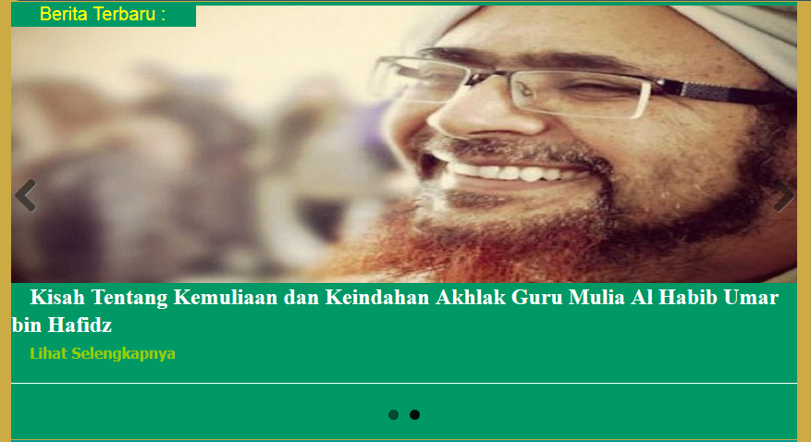 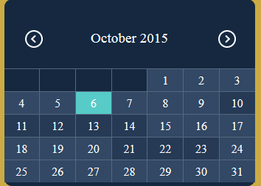

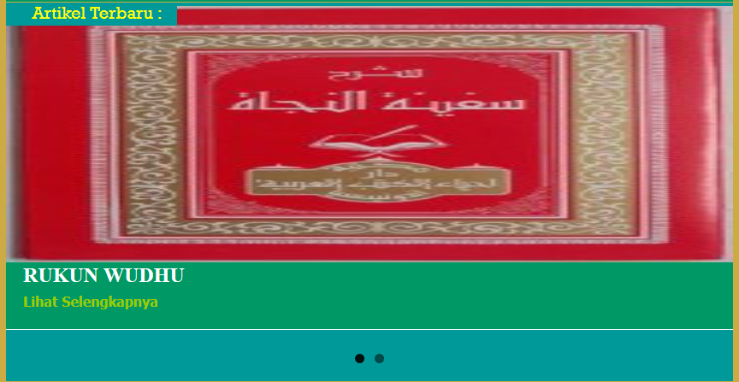 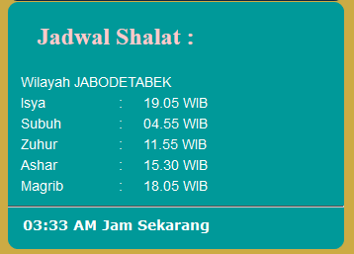



The following figure displays the tokoh.html page



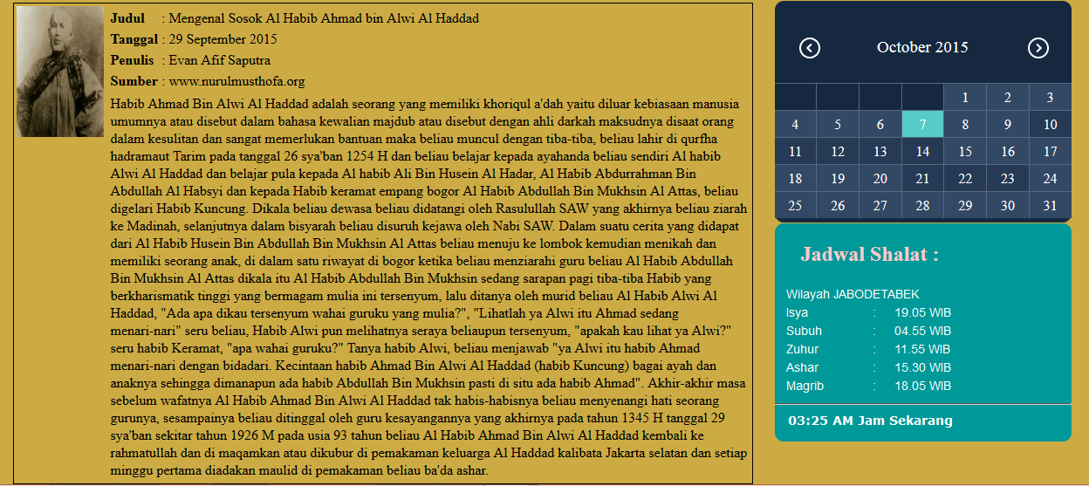

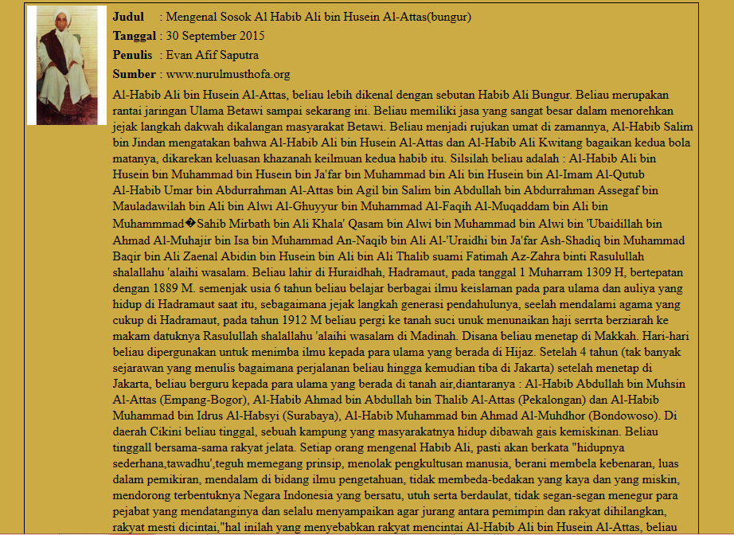

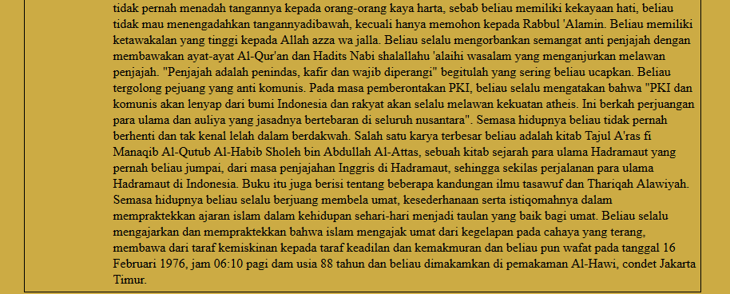

The following figure displays the kisah.html

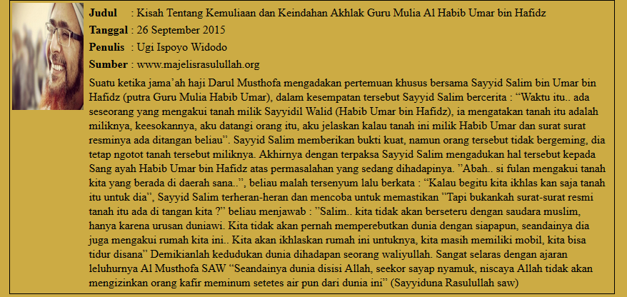

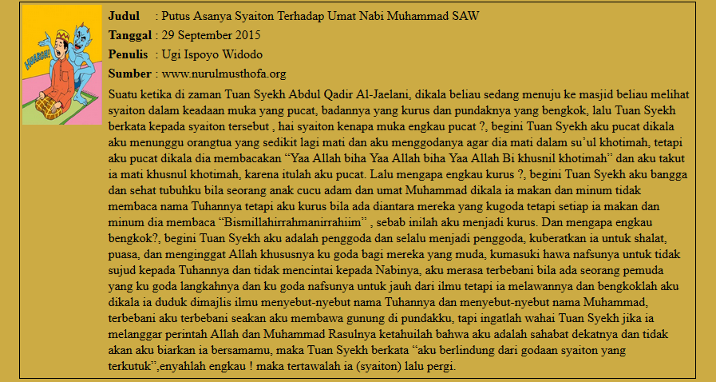

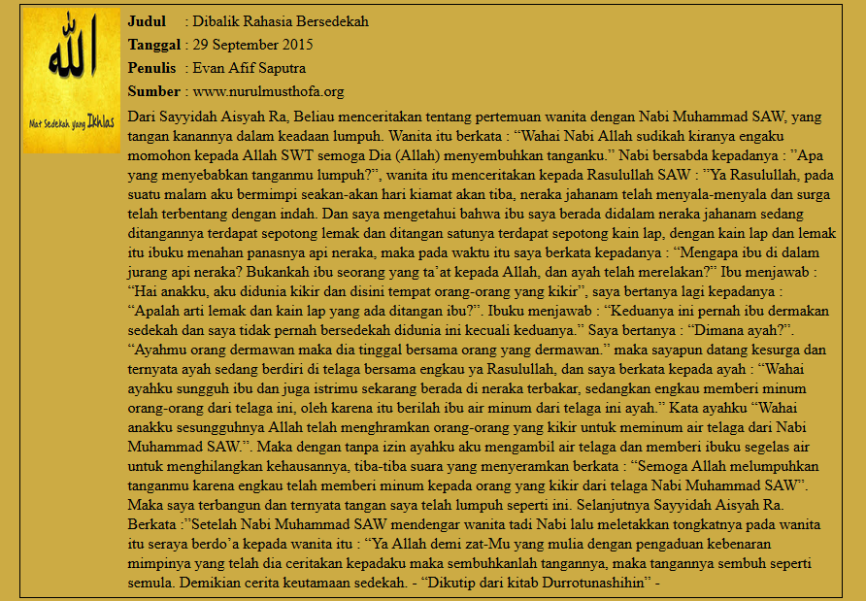

The following figure displays the fiqih.html

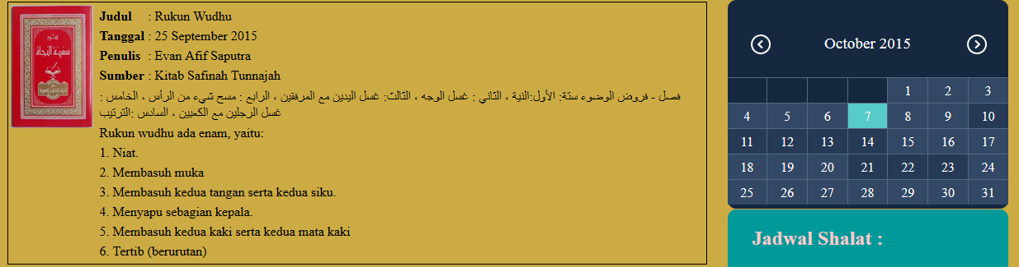

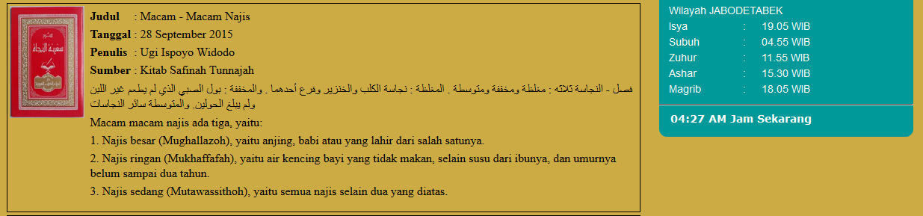

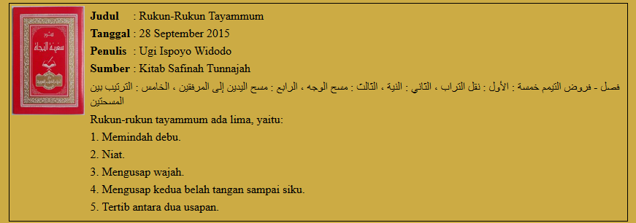

The following figure displays the hadits.html

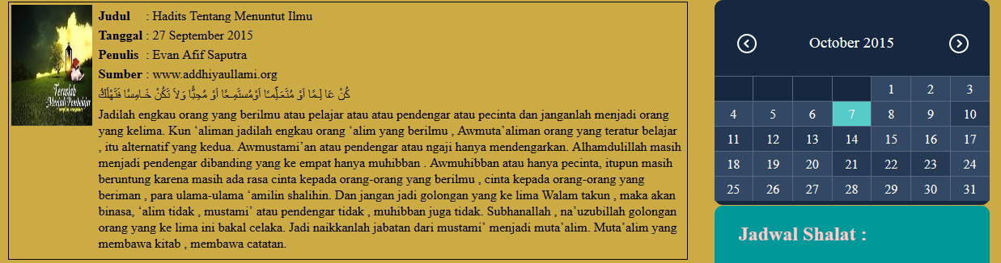

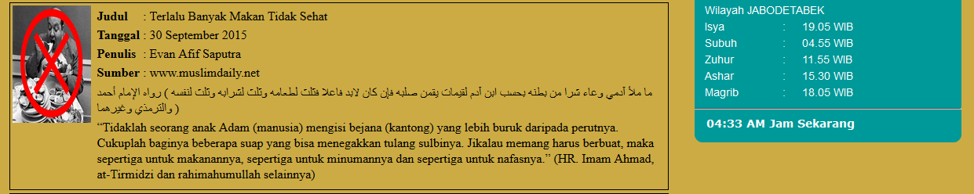

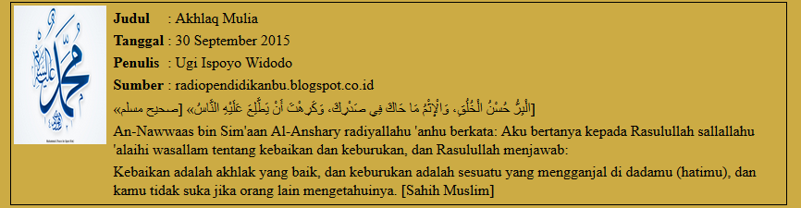

The following figure displays the sejarah.html

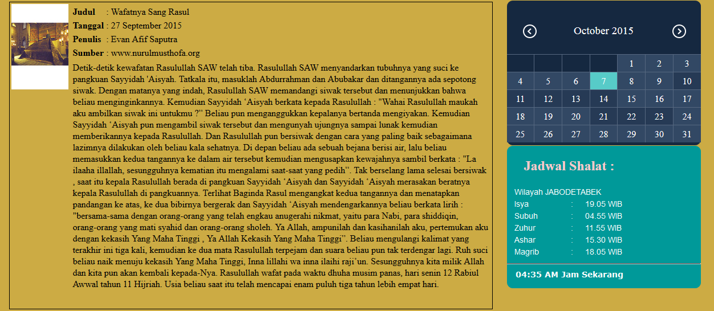

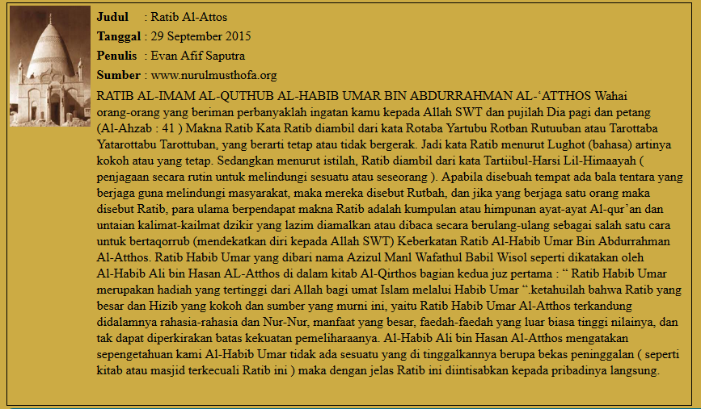

The following figure displays the jadwal.html

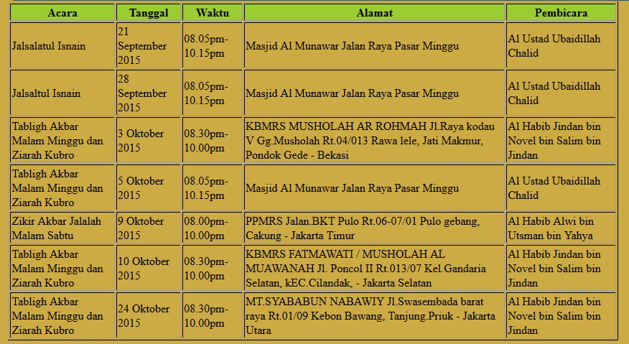 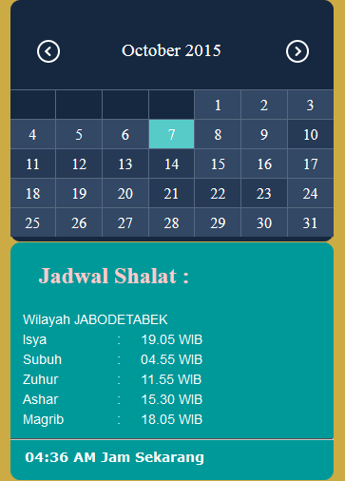

**Hardware** : Processor Intel®, Core™ i5   
: @1.7GHz   
: 4GB of Ram   
: CD ROM Drive  
: 500GB of HDD

**Operating system** : Microsoft Windows 8

**Software** : Sublime Text 2 & 3, Notepad++ 6.4.5,   
 Mozilla Firefox 38.0

**SYSTEM CONFIGURATION**

|  |  |  |
| --- | --- | --- |
| **S.No** | **File Name** | **Description** |
| 1 | index.html | Contains the code of main menu page interface of the Suara Santri website. |
| 2. | tokoh.html | Contains the code for description page interface of islamic personalities |
| 3. | kisah.html | Contains the code for description page interface of exemplary stories |
| 4. | fiqih.html | Contains the code for description page interface of fiqih(islamic in law) |
| 5. | hadits.html | Contains the code for “hadits” page |
| 6. | sejarah.html | Contains the code for description page interface of islamic stories |
| 7. | jadwal.html | Contains the code of islamic event page |
| 8. | berita.xml | Contains the article of ‘tokoh’ and ‘kisah’ page content |
| 9. | Artikel.xml | Contains the article of ‘fiqih’, ‘hadits’, and ‘sejarah’ page content |
| 10. | jadwal.xml | Contains the article of ‘jadwal’ page content |

**PROJECT FILE DETAILS**